Sprint 2 - Accuracy Design Document

November 24, 2020

Table of Contents
1. Executive Summary 3
1.1 Project Overview 3
1.2 Purpose and Scope of this Specification 3
2. Product/Service Description 3
2.1 Product Context 3
2.2 User Characteristics 3
2.3 Assumptions 4
2.4 Constraints 4
2.5 Dependencies 4
3. Requirements 4
3.1 Functional Requirements 4
3.2 Security 5
3.2.1 Protection 5
3.2.2 Authorization and Authentication 5
3.3 Portability 5
4. Requirements Confirmation/Stakeholder sign-off 5
5. System Design 5
5.1 Algorithm 5
5.2 System Flow 6
5.3 Software 8
5.4 Hardware 10
5.5 Test Plan 10
5.6 Task List/Gantt Chart 12
5.7 Staffing Plan 12

Executive Summary

Project Overview
This system design document encapsulates the second part of the three-part Robotics Project in CS-104: accuracy. The goal of the robotics project is to design and document three separate sprints that focus on endurance, accuracy, and speed. This project, referred to as Sprint 2 - Accuracy, focuses on the robot’s ability to navigate a figure-eight course. The accuracy sprint requires that a Sphero robot follows the figure-eight path five times and that the robot indicates the program’s end with sound and strobing lights. This project’s intended audience is Professor Eckert, all CS-104 sections, any faculty member or student part of the Monmouth University Computer Science and Software Engineering Department, and anyone with or without experience with an interest in coding and developing software and algorithms.

Purpose and Scope of this Specification
The purpose of this project is to design the software necessary for the robot to complete the accuracy course. In this sprint, the Sphero robot must demonstrate its ability to run around the figure-eight course five times. This project’s intended audience is Professor Eckert, all CS-104 sections, any faculty member or student part of the Monmouth University Computer Science and Software Engineering Department, and anyone with or without experience with an interest in coding and developing software and algorithms.
In Scope
This document addresses requirements related to Phase 2 of the Robotics Project:
- modification and execution of Sphero Edu code to meet the mandates of Sprint 2 – Accuracy
Out of Scope
The following items in Phases 1 and 3 of the Robotics Project are out of scope:
- modification and execution of Sphero Edu code to meet the mandates of Sprint 1 – Endurance (Phase 1)
- modification and execution of Sphero Edu code to meet the mandates of Sprint 3 – Agility (Phase 3)

Product/Service Description
The general factor affecting this product and its requirements is the ability of the robot to successfully pass the accuracy test. The robot must fulfill the requirements that the accuracy test calls for.

Product Context
In the context of other robotics products, this product is revolutionary because of its ease of use, simplistic, straightforward code, and extensive compatibility with almost any personal device. This product relates to this team’s two other products in that it is the second of three phases of the Robotics Project. It will be presented in the culmination of all three sprints called the Robotics Triathlon. This product is independent and self-contained; it is completed separately under a different schedule and plan than the other two sprints. This product is interfaced with a Sphero SPRK+ robot that runs the code behind this project. This product must pass the accuracy test.

User Characteristics
- Students/faculty/staff/other with or without experience with an interest in coding and developing software and algorithms
- New and experienced programmers who are interested in using unique frameworks such as the Sphero Edu platform. Sphero understands block code as well as JavaScript, so it is welcoming and provides options to new and experienced programmers.

Assumptions
It is assumed that:
- User has access to a Sphero SPRK+ robot as well as its required accessories: carrying case, charger block, charging cable, charging cradle, and silicone cover
- User has access to a Sphero-supported operating system/device
- Bluetooth capability of the parent device to facilitate a connection with the Sphero robot
- User knows how to operate and navigate the Sphero Edu application
- User has access to a Wi-Fi connection

Constraints
- Project deadline: Tuesday, November 24, 2020 at 01:00p.m.
- Team members’ schedules and availability
- Access to the Monmouth University campus is limited due to COVID-19 safety restrictions
  - The team decided that it is best to stay safe and complete this project off-campus
- The original accuracy course layout in Howard Hall (HH) 208 has a figure-eight course setup with two circles of 5-foot diameter. Due to the team’s inability to develop and test the software on-campus as well as the team’s space restrictions, the dimensions of the course had to be proportionately decreased to two circles of 2.5-foot diameter. The software still performs per the requirements.
- User must be in close proximity to the robot to maintain the Bluetooth connection; program will cease if user goes out of Bluetooth range

Dependencies
- Access to a Sphero SPRK+ robot
- Access to an up-to-date version of the Sphero Edu application on a phone, tablet, or computer
- Access to the latest version of the code for this project
- Access to a Wi-Fi network and a Bluetooth-enabled device to connect to the robot
- Access to an area large enough to have space for a figure-eight course comprised of two circles of 2.5-foot diameter

Requirements

Functional Requirements
Req# | Requirement | Comments | Priority | Date Rvwd | SME Reviewed / Approved
ACCUR_01 | Robot program must start while on the starting square | Necessary to stay within the figure-eight course and finish in the same spot | 1 | 11/20/20 | Joseph F.  Justyce G.
ACCUR_02 | Robot must follow and stay within the figure-eight course path five times | The robot exhibits its ability to accurately run the figure-eight course five times and stay on the path | 1 | 11/20/20 | Joseph F.  Justyce G.
ACCUR_03 | Robot must finish in the same spot it started | Shows that the robot stayed within the course successfully | 1 | 11/20/20 | Joseph F.  Justyce G.
ACCUR_04 | Robot must speak “I am the winner!” | Indicates completion of the loop (five runs around the figure-eight course) | 1 | 11/20/20 | Joseph F.  Justyce G.
ACCUR_05 | Robot must strobe multicolored lights for 5 seconds | Indicates completion of the entire program | 1 | 11/20/20 | Joseph F.  Justyce G.

Security

Protection
- Individual accounts on the Sphero Edu and GitHub platforms are associated with a personal email and secure password; log-in information is processed and encrypted through HTTPS for security
- Access to edit the code and contribute to this project is limited to group members via account-specific sharing on Sphero Edu and GitHub
- Sensor data is stored locally
- The Sphero robot is signed out through the Monmouth University Computer Science and Software Engineering Department and is only available for use by the team it is assigned to
- The Sphero robot has a carrying case to protect and safely store it
- The Sphero robot has a silicone cover to protect it from scratches and increase grip

Authorization and Authentication
- Individual accounts on the Sphero Edu platform associated with an e-mail address and password allow access to create and share code
- Individual accounts on GitHub associated with an e-mail address and password to collaborate and share code with team members through a collaboration branch

Portability
- The Sphero Edu block code relevant to this project is portable to supported devices and operating systems because it can be accessed seamlessly through the Sphero Edu platform or GitHub
- A copy of the Sphero Edu block code is available in this document as well as this project’s public GitHub repository, thus the code can be replicated by anyone
- The Sphero SPRK+ robot that executes code is portable due to its small form-factor and can run this software in a small area

Requirements Confirmation/Stakeholder sign-off

Meeting Date | Attendees (name and role) | Comments
11/10/20 | Joseph Furmanowski (Project Manager)  Justyce Graham (Programmer) | Confirmed ACCUR_01 through ACCUR_05

System Design

Algorithm
- Start program when robot is on the starting square
- Robot spins 360 degrees for 5 seconds at 50 speed
- Robot stops
- Robot spins -360 degrees for 5 seconds at 50 speed
- Robot stops
- Loop/repeat the 4 steps above 5 times
- Robot says, “I am the winner!”
- Robot strobes red LED light once for 1 second
- Robot strobes orange LED light once for 1 second
- Robot strobes yellow LED light once for 1 second
- Robot strobes green LED light once for 1 second
- Robot strobes blue LED light once for 1 second
- End the program

System Flow
- See next page for system flow chart

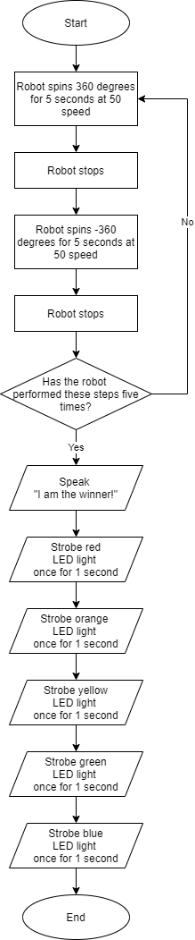

Software
- Sphero Edu App
  - Allows for the creation, development, sharing, and updating of code for the robot
- Block coding
  - Simple commands that the robot follows
  - Block coding is an abstraction of the JavaScript language that is behind the blocks
- GitHub
  - Facilitates collaboration and updates from all team members
- Sphero block code
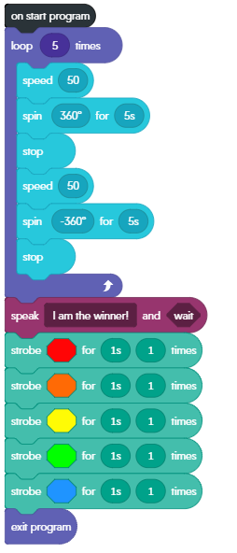
- Sensor data
  - See next pages for robot sensor data

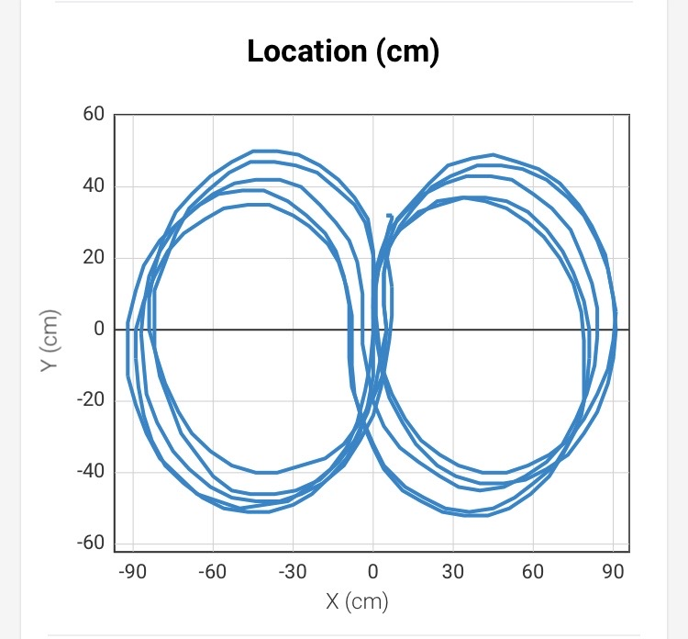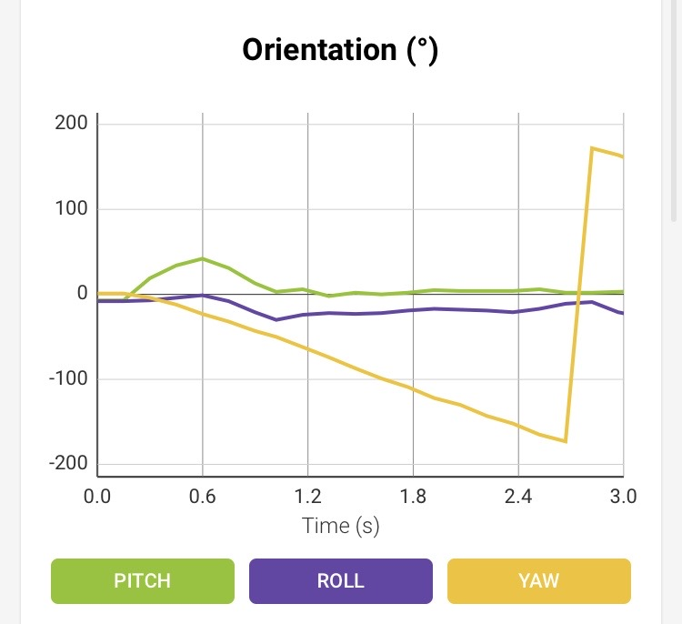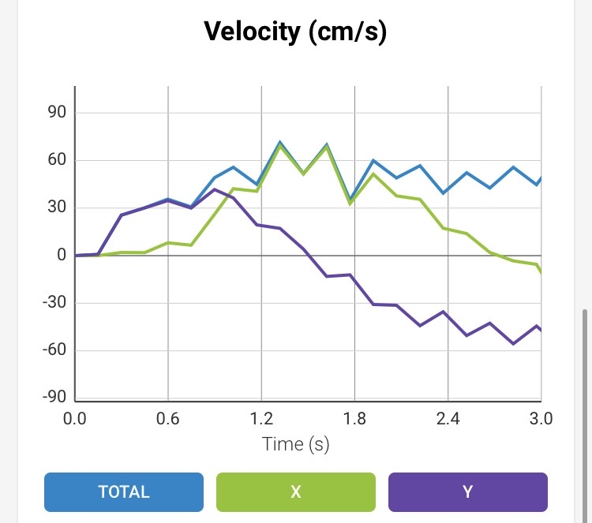
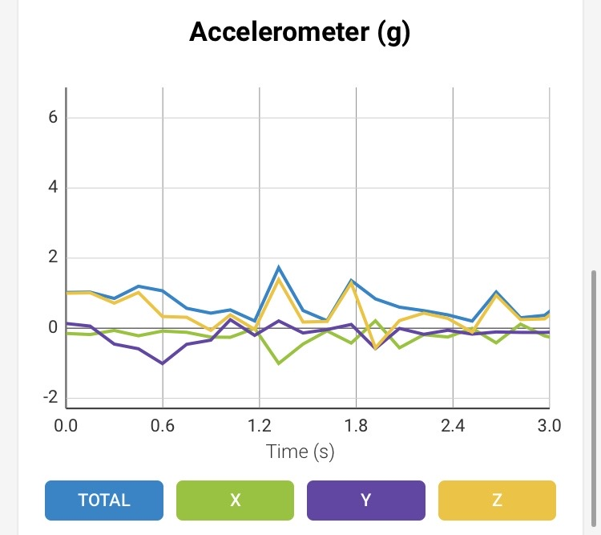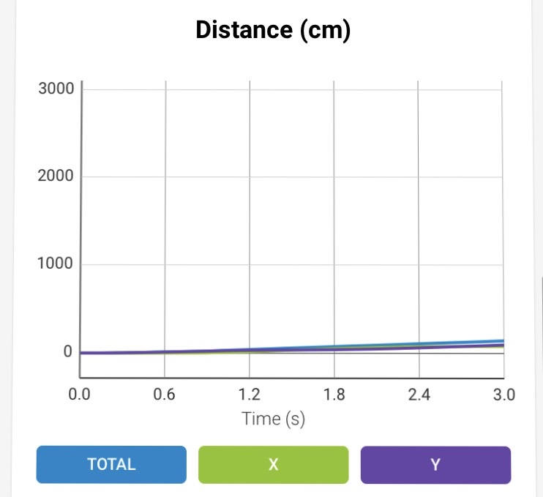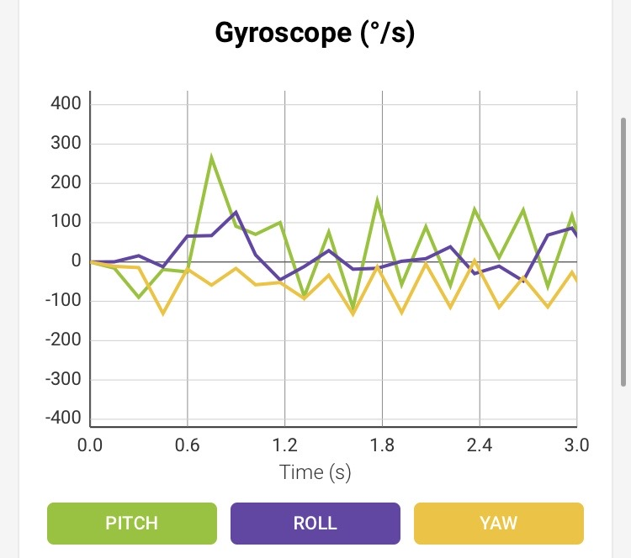

Hardware
- Personal computers running Microsoft Windows 10 and Mac OS developed the application
- An Apple iPhone 6s running iOS 13.3.1 connected to Sphero via Bluetooth tested the application
- A Sphero SPRK+ robot (SK-36FC) borrowed from the Monmouth University Computer Science and Software Engineering Department demonstrated and performed the program

Test Plan

Reason for Test Case | Test Date | Expected Output | Observed Output | Staff Name | Pass/Fail
Robot stays within the figure-eight path in the first run | 11/22/20 | Robot stays within the figure-eight path in the first run | Robot did not stay within the figure-eight path in the first run; it went too far off course | Joseph F. | Fail
Robot stays within the figure-eight path in the first run after modifying speed and spin time | 11/22/20 | Robot stays within the figure-eight path in the first run | Robot stayed within the figure-eight path in the first run | Joseph F. | Pass
Robot stays within the figure-eight path in the second run | 11/22/20 | Robot stays within the figure-eight path in the second run | Robot stayed within the figure-eight path in the second run | Joseph F. | Pass
Robot stays within the figure-eight path in the third run | 11/22/20 | Robot stays within the figure-eight path in the third run | Robot stayed within the figure-eight path in the third run | Joseph F. | Pass
Robot stays within the figure-eight path in the fourth run | 11/22/20 | Robot stays within the figure-eight path in the fourth run | Robot stayed within the figure-eight path in the fourth run | Joseph F. | Pass
Robot stays within the figure-eight path in the fifth run | 11/22/20 | Robot stays within the figure-eight path in the fifth run | Robot stayed within the figure-eight path in the fifth run | Joseph F. | Pass
Robot speaks, “I am the winner!” after running around the figure-eight course 5 times | 11/22/20 | Robot speaks, “I am the winner!” after running around the figure-eight course 5 times | Robot did not speak, “I am the winner!” after running around the figure-eight course 5 times | Joseph F. | Fail
Robot speaks, “I am the winner!” after running around the figure-eight course 5 times after volume adjustments | 11/22/20 | Robot speaks, “I am the winner!” after running around the figure-eight course 5 times after volume adjustments | Robot clearly and audibly spoke, “I am the winner!” after running around the figure-eight course 5 times after volume adjustments | Joseph F. | Pass
Robot stops where it started (between the two parts of the figure-eight) | 11/22/20 | Robot stops where it started | Robot stopped near where it started | Joseph F. | Pass
Robot strobes red LED light once for 1 second | 11/22/20 | Robot strobes red LED light once for 1 second | Robot strobed red LED light once for 1 second | Joseph F. | Pass
Robot strobes orange LED light once for 1 second | 11/22/20 | Robot strobes orange LED light once for 1 second | Robot strobed orange LED light once for 1 second | Joseph F. | Pass
Robot strobes yellow LED light once for 1 second | 11/22/20 | Robot strobes yellow LED light once for 1 second | Robot strobed yellow LED light once for 1 second | Joseph F. | Pass
Robot strobes green LED light once for 1 second | 11/22/20 | Robot strobes green LED light once for 1 second | Robot strobed green LED light once for 1 second | Joseph F. | Pass
Robot strobes blue LED light once for 1 second | 11/22/20 | Robot strobes blue LED light once for 1 second | Robot strobed blue LED light once for 1 second | Joseph F. | Pass

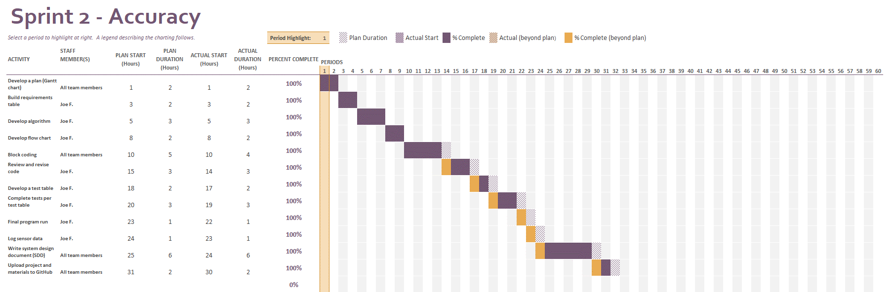
Task List/Gantt Chart

Staffing Plan

Name | Role | Responsibility | Reports To
Joseph Furmanowski | Project Manager,  Programmer | - Oversee project and maintain quality control  - Develop a plan  - Build requirements table  - Develop flow chart  - Write code  - Execute, test, and revise code and algorithm  - Log sensor data  - Write SDD  - Collaborate via GitHub | - Professor Eckert
Justyce Graham | Programmer,  Task Planner | - Develop a plan  - Finalize the Gantt chart and verify that it suits the project  - Contribute to the SDD (Sections 1 and 2)  - Write code  - Collaborate via GitHub | - Professor Eckert  - Project Manager

